Purpose
To describe how plant and equipment shall be isolated to control the risk of a hazardous energy release.

Scope
This procedure applies to all assets and premises owned, leased or occupied by Melbourne Water employees and contractors.
An Isolation Permit is required when the isolation of an energy source has to be authorised or implemented by a Permit Authoriser.
An Isolation Permit is not required for the like for like replacement of the following domestic equipment in office, kitchen and bathroom environments:
  - Lighting tubes and globes by a qualified Electrician
  - Appliances which can be unplugged from a general power outlet
  - Plumbing equipment which has a single water source in vicinity of asset and can be unplugged from a general power outlet by a qualified Plumber
Section 5 - Lock Out Tag Out Procedure shall be followed for all these works

Isolation Examples
Type | Description | Isolation Example
Mechanical/ Hydraulic | To isolate flows within a drain, pipe, vent or duct | Valves, actuators, penstocks  Inflatable/ drainers plugs
Electrical | To open a circuit to prevent electrical flow | Fuse/ cartridge removal  Racking out  Turning off a circuit breaker/ local isolator switch  Physical air gap between contacts
Constructed | The physical construction of an isolation to prevent materials (liquids or solids) from entering a work area | Sandbags  Drop boards, weir plates  Coffer dams
Line/ product freezing | Creation of a temporary isolation | Using liquid nitrogen to freeze fluid running through a pipe to create a temporary ice plug isolation
Energy controlled | Control or reduce an energy source to facilitate a safe work area | Controlling and reducing flows within an aqueduct, sewer, pipe or drain to facilitate safe entry with appropriate controls

Minimum Isolation Standard
All isolation points must have the ability to be proved. This means that the effectiveness of the isolation can be verified by either physical separation or an appropriate testing method.
This includes non-intrusive electrical isolations which must be verified prior to work commencing.
The following mechanical/ hydraulic isolations are deemed to meet the Minimum Isolation Standard:

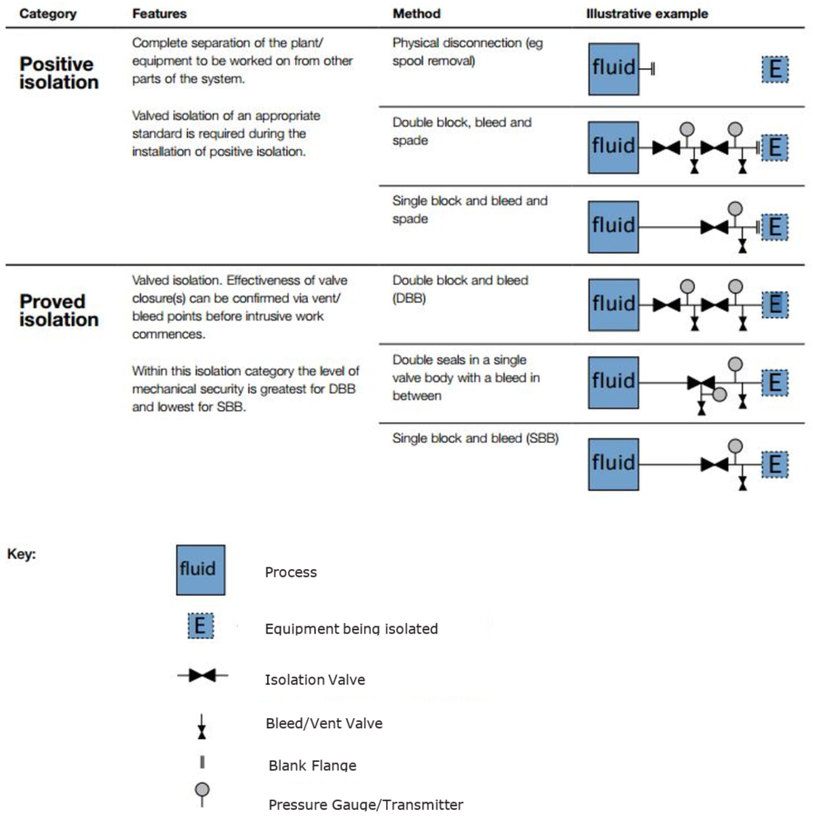

Verification of Isolations
Minimum verification of isolations must include:
- Confirming that no identification errors were made (correct isolator or valve).
- Ensuring all stored energy is dissipated or restrained.
- Testing for zero energy state for all potential energy sources.

Examples of verifying isolations may include:
- Observing a change of state of energy when isolating.
- Ensuring buried/ concealed assets are positively identified using appropriate technology before proceeding with penetrative works on an isolated asset.

The person completing the isolation is responsible for ensuring the isolation is verified.

Unproved Isolations
An isolation which does not have the ability to be verified is considered to be an unproved isolation.
If any isolation points cannot be verified Section 6 – Unproved Isolation Process must be followed.
Examples of unproved isolations:

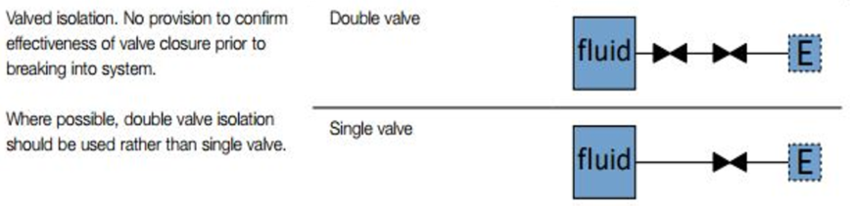

Process
Equipment being isolated
Isolation Valve
Bleed/Vent Valve
Blank Flange
Pressure Gauge/Transmitter

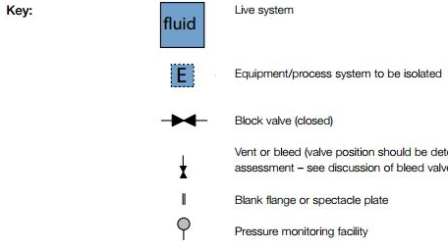

Documented Isolation Plans
Consider the need for a documented isolation plan when:
- Works are unplanned, unscheduled or under significant time pressures
- There are significant process implications
- There are isolations with hold points or inspection test plans
- There are isolations on Dangerous Goods installations

Documented isolation plans should contain:
- All process steps required to prepare the equipment for removal from service
- All isolation steps required to safely remove the piece of equipment from service
- Any hold points/ inspection test plans where work should pause and be assessed by all relevant parties.

Documented isolation plans should:
- Use Isolation Plan template
- Be peer reviewed before being carried out
- Communicated with all relevant parties
- Retained for future reference if the isolation plan is likely to be needed again by creating a documented Standard Isolation Procedure

Unproved Isolation Process
When the proposed isolations cannot be verified, and there is not already a documented isolation plan the following process needs to be followed:

Plant Shutdown
When practicable, a plant shutdown should be considered to carry out the required work. A shutdown requires all hazardous sources to be isolated from the proposed worksite.
The scope of this option is dependent on the site’s complexity, and the feasibility of conducting a plant shutdown should be determined on a case by case basis, before work is carried out.
Consider the option to implement a permanent modification for future works.

Extend Isolation
If the available isolation points do not have the ability to be verified, an extension of the isolation must be considered.
The isolation plan needs to incorporate upstream/downstream isolation points until the isolations can be verified.

Plant Modification
A plant modification should be considered to give all isolation points the ability to be verified.
Asset Management must be involved at this stage to ensure all ‘Management of Change’ requirements are met. An example of this would be installing Hot Taps in pipework between two isolation valves.
A plant modification must be treated as a unique task and also follow this standard when being carried out.

Approval of Unproven Isolations
After all of the above options have been exhausted, a risk assessed documented isolation plan must be produced for the Permit Operating Authority (POA) to review.
The POA has the authority to either approve or deny the request. Regardless of the outcome, the POA must log the event in IRIS as an event which will be raised at the next WPOA meeting to capture business wide relevant learnings.

Managing Isolation Activities

Documentation used for isolations
Accurate reference information is vital for planning and implementing isolations. All Melbourne Water sites shall maintain the following documentation at all times and ensure it is updated when plant modifications occur:
- Piping and Instrumentation Diagrams (P&IDs)
- Single Line Diagrams
- Cause and Effect diagrams
- Loop Diagrams
- Piping general arrangements
- As Built/ Constructed drawings

Intrusive Electrical Isolations
To conduct intrusive isolations where live electrical conductors or components may present during the isolation activity, an individual must:
- be a qualified A Grade Electrician, or
- hold a current Victorian Restricted Electrical Licence (REL) licence, or
- have a Statement of Attainment and signed off by the Melbourne Water Permit Operating Authority and Safety team via Verification of Competency (VOC) every 2 years.
Table 1: Examples of Intrusive vs. Non- Intrusive Electrical Isolations
Intrusive | Non-Intrusive
Removing Bolt-In Fuses | Switching off an Electrical Isolator
Accessing a live electrical panel to remove cartridge fuses | Accessing an electrical cabinet/ switchboard to turn off a circuit breaker where conductor or components are behind protected covers
 | Removing a Plug from a GPO
If the Permit Authoriser does not have the required A Grade or Restricted Electrical license, they can use a suitably qualified electrical technician to carry out the electrical isolations listed in the Isolation Plan.

High Voltage Electrical Isolations
All High Voltage Isolations are to be carried out in accordance with the Code of Practice on Electrical safety for working on or near High Voltage Electrical Apparatus, ‘The Blue Book’ and High Voltage Procedure

Live Electrical work
All live electrical work is to be carried out in accordance with AS/NZS 4836 and the Electrical Safety (General) Regulations 2019 Division 4 by appropriately licenced personnel.

Dynamic Isolations
A Dynamic Isolation can only be performed by a person who has completed the Melbourne Water Dynamic Isolation Training and Authorisation course. Participants are required to demonstrate competence of:
  - When the Dynamic Isolation process does and doesn’t apply
  - LOTO requirements for these types of isolations
  - Isolation planning requirements
  - What to do when the scope of work changes
  - The authority and responsibility of managing dynamic isolations

Dynamic isolations are limited to one shift and must not result in plant wide operational or process impacts.

Dynamic Isolations do not require an Isolation Permit if the requirements of the below decision tool are met and Section 5 - Lock Out Tag Out Procedure is adhered to

References
Document title
High Voltage Procedure
Lock Out Tag Out (LOTO) Procedure
Isolation Permit Procedure
Good to Go Procedure
AS/NZS 4836 – Safe Working on or near Low-Voltage Electrical Installations

Document History
Date | Reviewed/  Actioned By | Version | Action
March 2024 | Senior Manager Safety, Service Delivery | 15 | Updated link, minor typo and document history to reflect current version and date.
March 2024 | Senior Manager Safety, Service Delivery | 13,14 | No content change, updated document history to reflect current version and date.
August 2023 | Senior Manager Safety, Service Delivery | 12 | No content change, updated document history to reflect current version and date.
July 2023 | Senior Safety Manager Service Delivery | 11 | Added ref to domestic appliances, REL & VOC, templates & links added
March 2023 | Senior Safety Manager Service Delivery | 10 | Content review and update
February 2022 | Systems Integration Specialist | 9 | Official sensitivity markings
February 2021 | Information Quality Coordinator | 8 | Updated header, date & version Number. No content change.

